CreateAssembly Program User’s Guide

5/29/2018

Table of Contents

1 Introduction 2

2 Architecture 3

3 Global Coordinate System 3

4 Kinematic Joint Types 5

5 FEA Analysis 6

5.1 Patran-Nastran Solution 6

5.2 Request Volume and Mass for a Plate Model 6

6 General Purpose Parameters Requesting Special Processing 8

6.1 Export_All_Component_Points 8

7 Material Properties 10

7.1 Composites 10

7.1.1 General Composite Properties 10

7.1.2 IM7_8551_7_Carbon_Epoxy 10

7.1.3 T300_PR319_Carbon_Epoxy 10

8 Simplified Representations 10

8.1 Creo Model Setup 10

8.2 Test Bench 12

9 Export CAD Representations (e.g. STEP, Parasolid, etc.) 13

Appendix A – Links 15

10 Parameters 15

Appendix B – Exporting Wavefront Formatted File Via Toolkit 17

Figures

Figure 1 – CreateAssembly Architecture 3

Figure 2 - Reference Coordinate System in a CyPhy Assembly 4

Figure 3 – Reference Coordinate System Connection in a CyPhy Assembly 4

Figure 4 - Reference Coordinate System Connection in a CyPhy Component 5

Figure 5 – Example PATRAN_NASTRAN Test Bench Requesting Mass and Volume 7

Figure 6 – Example testbench_manifest.json with Mass and Volume 8

Figure 7 – Export_All_Component_Points Test Bench Example 9

Figure 8 – Component Example with Points Necessary for Export_All_Component_Points 10

Figure 9 – Creo View “Manage Views” 11

Figure 10 Creo “Master Rep” Setting 12

Figure 11 DEFAULT_REP Specified in a Test Bench 12

Figure 12 Test Bench Types that Have Been Verified to Work with DEFAULT_REP 13

Figure 13 – Test Bench Requesting the Export of All Supported CAD Formats 15

Tables

Table 1 – Kinematic Joints 6

Revision History

|  |  |  |
| --- | --- | --- |
| **Date** | **Developer** | **Modifications** |
| 4/7/2017 | Robert O. | Initial Draft |
| 5/29/2018 | Robert O. | Added information about how parameters are handled. |
|  |  |  |
|  |  |  |

# Introduction

The document is a user’s guide for the program “CADCreoParametricCreateAssembly.exe”, which hereafter in this document is referred to as the CreateAssembly program.

The CreateAssembly program takes inputs based on CyPhy models and

1. Builds Creo assemblies
2. Outputs data (e.g. mass properties, transformation matrices between parts/sub-assemblies, etc.) about the created assemblies
3. Creates FEA meshes along with loads and constraints for structural Test Benches
4. Computes requested data (e.g. point locations, bounding boxes, mass properties)

# Architecture

Figure 1 shows the architecture for the CreateAssembly program. The CADAssembly.xml describes the assembly hierarchy and the constraints between parts/sub-assemblies and is the main input to the CreateAssembly program. The main output is the CAD assembly in the native CAD format. Additional outputs are the CAD assembly in other formats (e.g. STEP) and meta data about the assembly.



Figure 1 – CreateAssembly Architecture

# Global Coordinate System

The CreateAssembly program creates an empty Creo assembly and adds components (i.e. parts/sub-assemblies) to that assembly. The first component added is constrained by aligning the datums (for parts RIGHT, TOP, FRONT, and for assemblies ASM_RIGHT, ASM_ TOP, ASM_FRONT) in the added component to the empty assembly datums (ASM_RIGHT, ASM_ TOP, ASM_FRONT). The next added component would typically be constrained to the first component.

There is a way to specify which component is added first. In doing, so the user has control over the global coordinate system, because the first added component coordinate system would align with the coordinate system of the empty assembly. This is true because the datums RIGHT, TOP, FRONT are aligned with the coordinate system of the part and datums ASM_RIGHT, ASM_ TOP, ASM_FRONT are aligned with the coordinate system of the assembly.

To control which part is added first, the component assembly must have a ReferenceCoordinateSystem as shown in Figure 2.

Note – If the component assembly has more than one ReferenceCoordinateSystem, then it is arbitrary as to which component with a ReferenceCoordinateSystem would be added first.

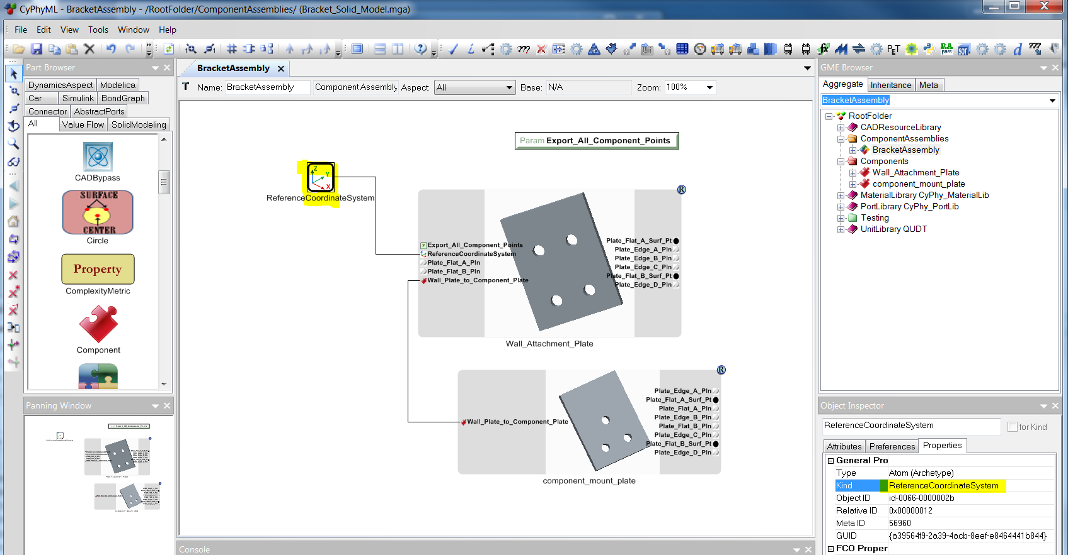

Figure 2 - Reference Coordinate System in a CyPhy Assembly

Within the component assembly, the ReferenceCoordinateSystem must be connected to a CoordinateSystem via a PortComposition line as shown in Figure 3.

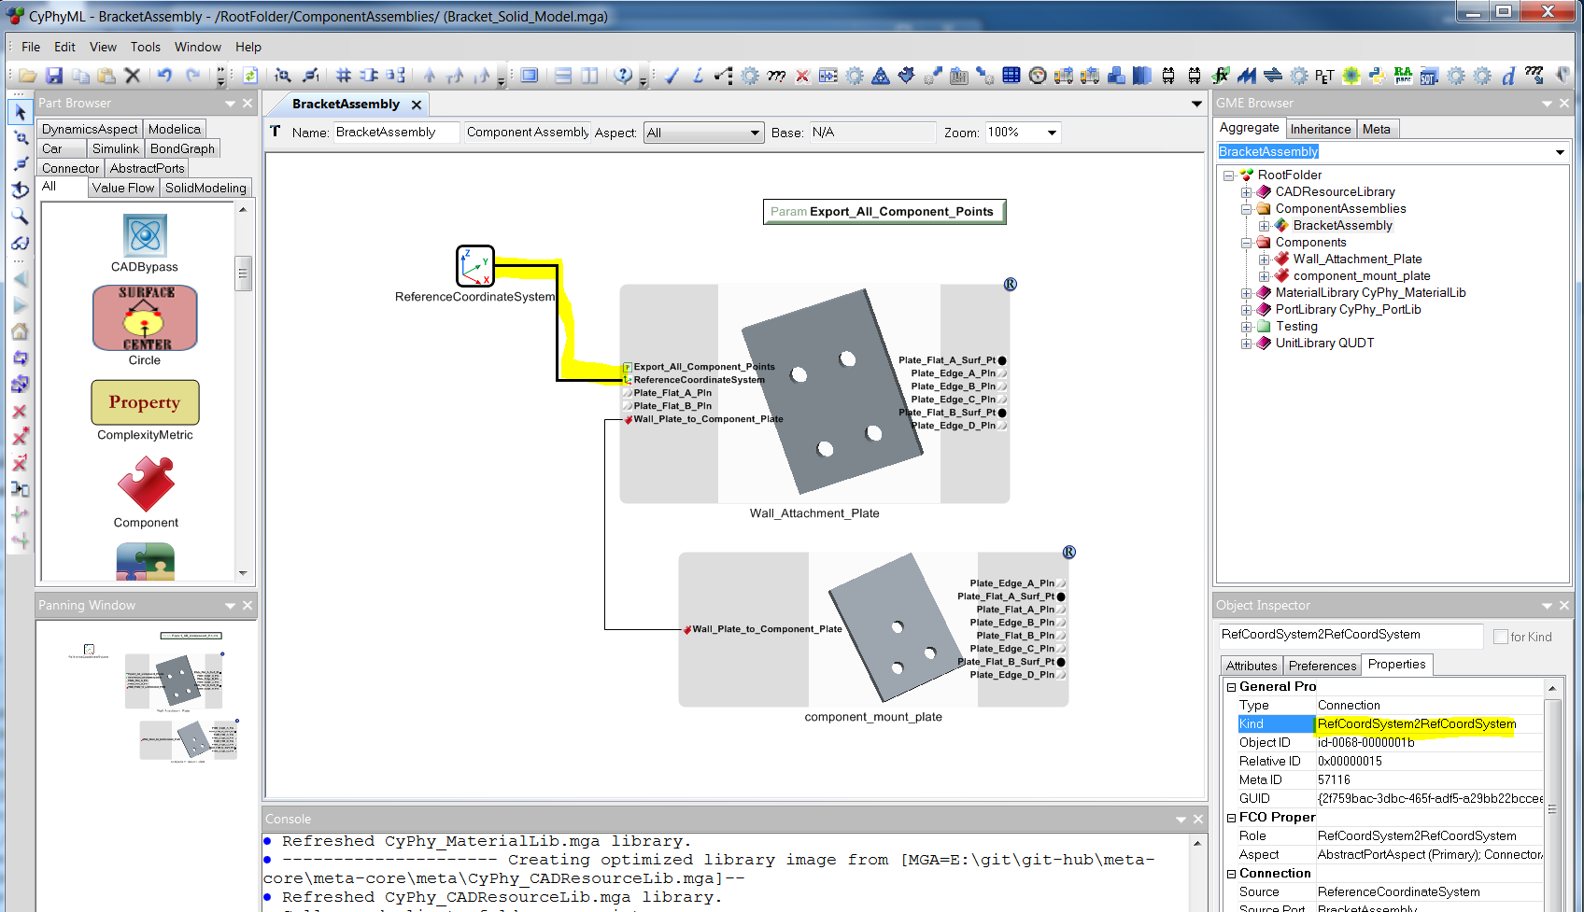

Figure 3 – Reference Coordinate System Connection in a CyPhy Assembly

Within the component, the ReferenceCoordinateSystem must be connected to a CoordinateSystem via a PortComposition line as shown in Figure 4.

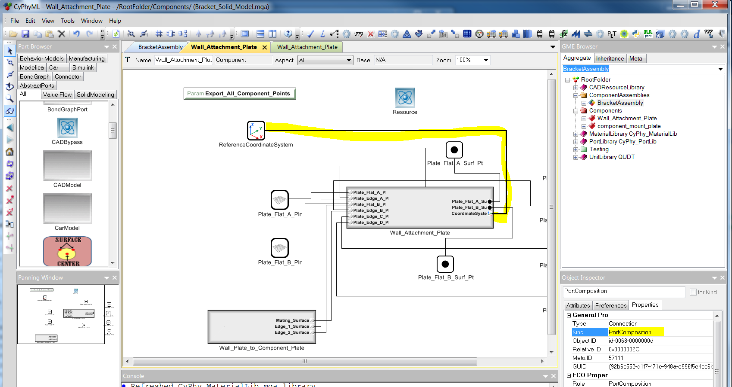

Figure 4 - Reference Coordinate System Connection in a CyPhy Component

# Kinematic Joint Types

For the kinematic joints shown in Table 1, the CreateAssembly program will automatically determine the joint type and create the appropriate constraint in Creo. For example, if the constraint consists of an axis and plane, the CreateAssembly would create a pin constraint in the Creo model.

Additionally, guides can be used to set a particular orientation. For example, a pin constraint would typically be composed of an axis and plane. A guide could be applied that would set the initial orientation of the model relative to the rotation axis. For this case, the guide would typically be a plane where the axis would lie in the plane and thus the plane would specify the initial orientation about the axis. The guide is only used to determine the initial position and never results in an entity in the CAD model constraint.

|  |  |  |  |
| --- | --- | --- | --- |
| **Creo Joint Name** | **Common Joint Name** | **Required Geometry** | **Comments** |
| Pin | Revolute | Axis and (Point or Plane) |  |
| Cylinder | Cylindrical | Axis |  |
| Slider | Prismatic | Axis and Plane |  |
| Planar | Planar | Plane | Creo supports further restrictions (i.e. additional planes) but we will assume the classical definition (three degrees of freedom, x, y, rotation around z) of a planar constraint. |
| Ball | Spherical | Point | Creo supports other geometry types, but currently only point is supported. |

Table 1 – Kinematic Joints

# FEA Analysis

## Patran-Nastran Solution

## Request Volume and Mass for a Plate Model

Typically, for a solid model, Creo knows the mass and volume information and this information is available from the metrics file. However, for surface models, only the FEA application knows the mass and volume information. This is because the FEA model has the plate thickness information along with the material density, and thus can compute the mass/volume for the entire FEA model.

To request that the volume and mass be computed for Patran_Nastran plate/surface model solutions, the following must be present in the Testbench.

1. Metrics added to the Testbench. Note – Strings are case insensitive
2. FEA_Total_Volume
3. FEA_Total_Mass
4. SolverType = PATRAN_NASTRAN
5. ElementType = Plate4/8

An example Testbench is shown in Figure 5.

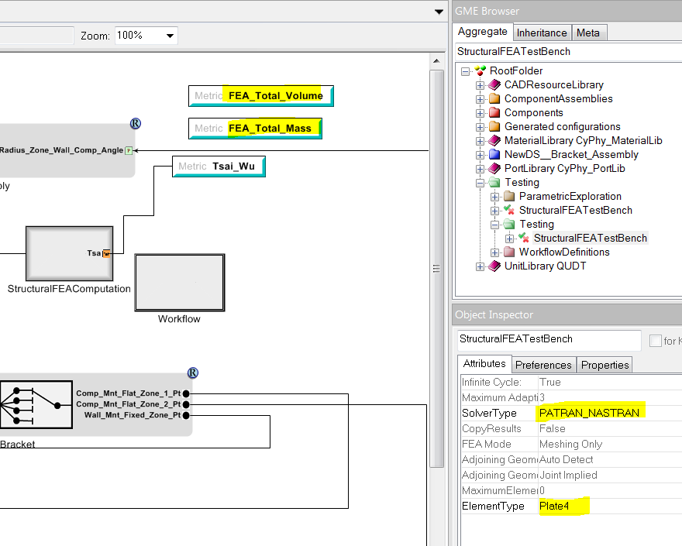

Figure 5 – Example PATRAN_NASTRAN Test Bench Requesting Mass and Volume

Once the TestBench runs, the computed values will be in testbench_manifest.json as shown in Figure 6.

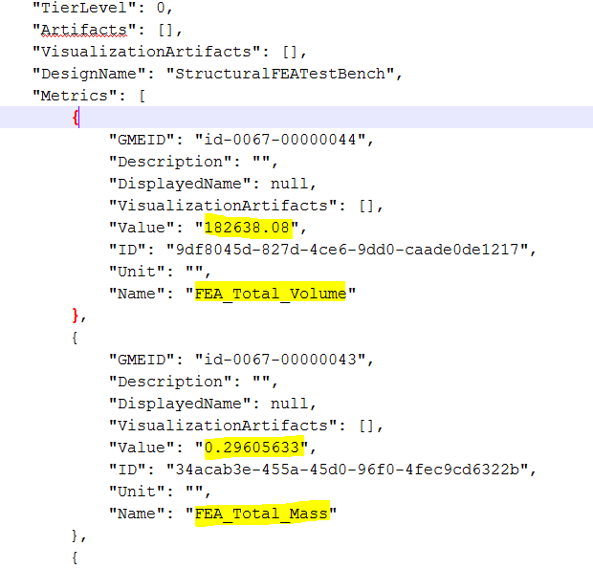

Figure 6 – Example testbench_manifest.json with Mass and Volume

# General Purpose Parameters Requesting Special Processing

## Export_All_Component_Points

There was a need to export all points at the component level without explicitly calling out a metric in the TestBench for each point. Adding a parameter titled as follows will result in CyPhytoCAD_CSharp adding instructions in CADAssembly.xml to compute the coordinates of all points in the component. The points must be a Kind=Point and Role=Point in the component and must be connected to a point in the CADModel icon.

Export_All_Component_Points Note – This is case sensitive.

The point coordinates will appear in ComputedValues.xml after the Test Bench successfully runs.

Note – Currently at least one point metric must be requested in addition to Export_All_Component_Points. Requiring the request for at least one point metric is due to a bug and will be corrected. The two items (Export_All_Component_Points and at least one point metric) in yellow in Figure 7 must be present.

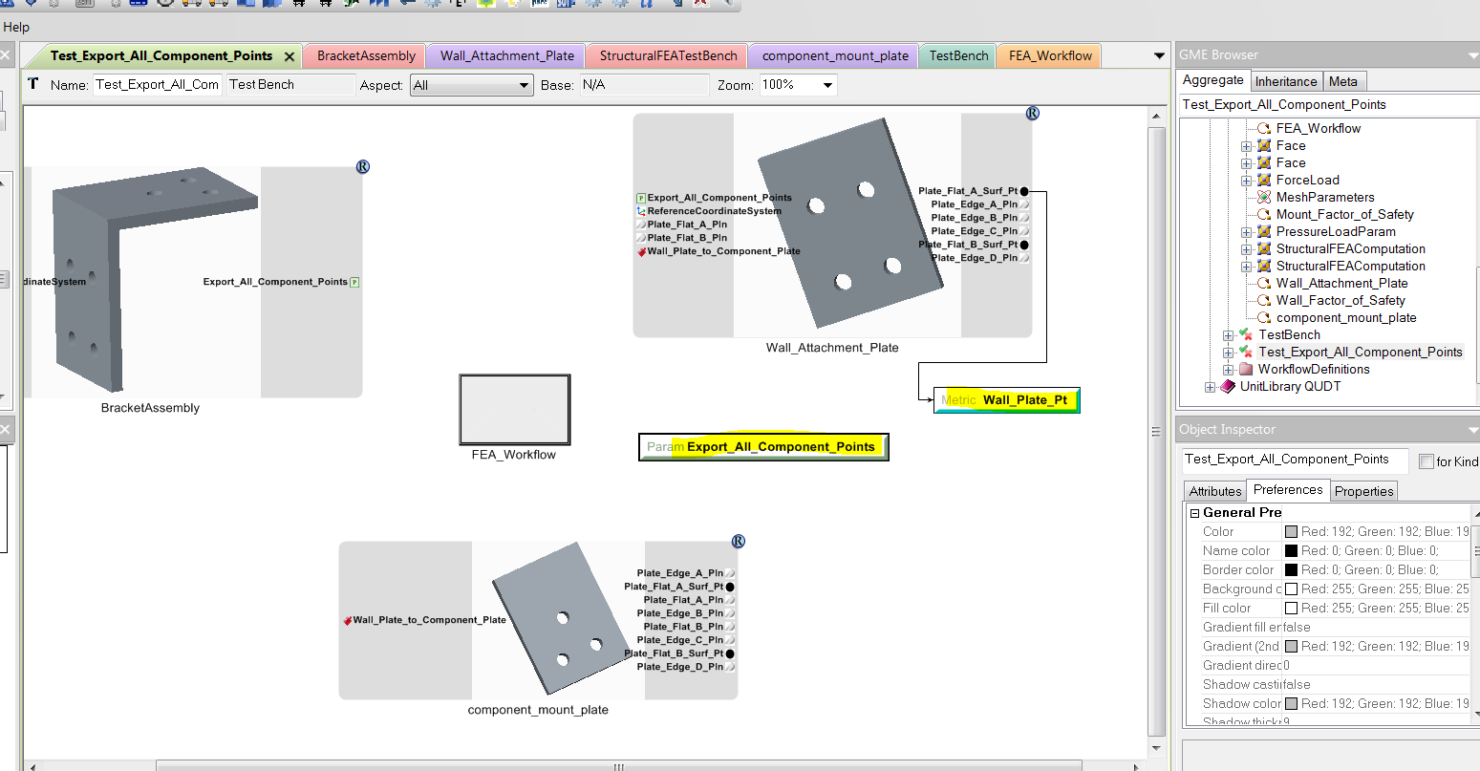

Figure 7 – Export_All_Component_Points Test Bench Example

Once the Testbench runs, ComputedValues.xml will contain the point coordinates.

The points must be referenced (brought out) in the component as shown in Figure 8. The highlighted in- yellow points will be in ComputedValues.xml along with their coordinates. Points in the CAD component that are not brought out to the component level will not be in ComputedValues.xml.

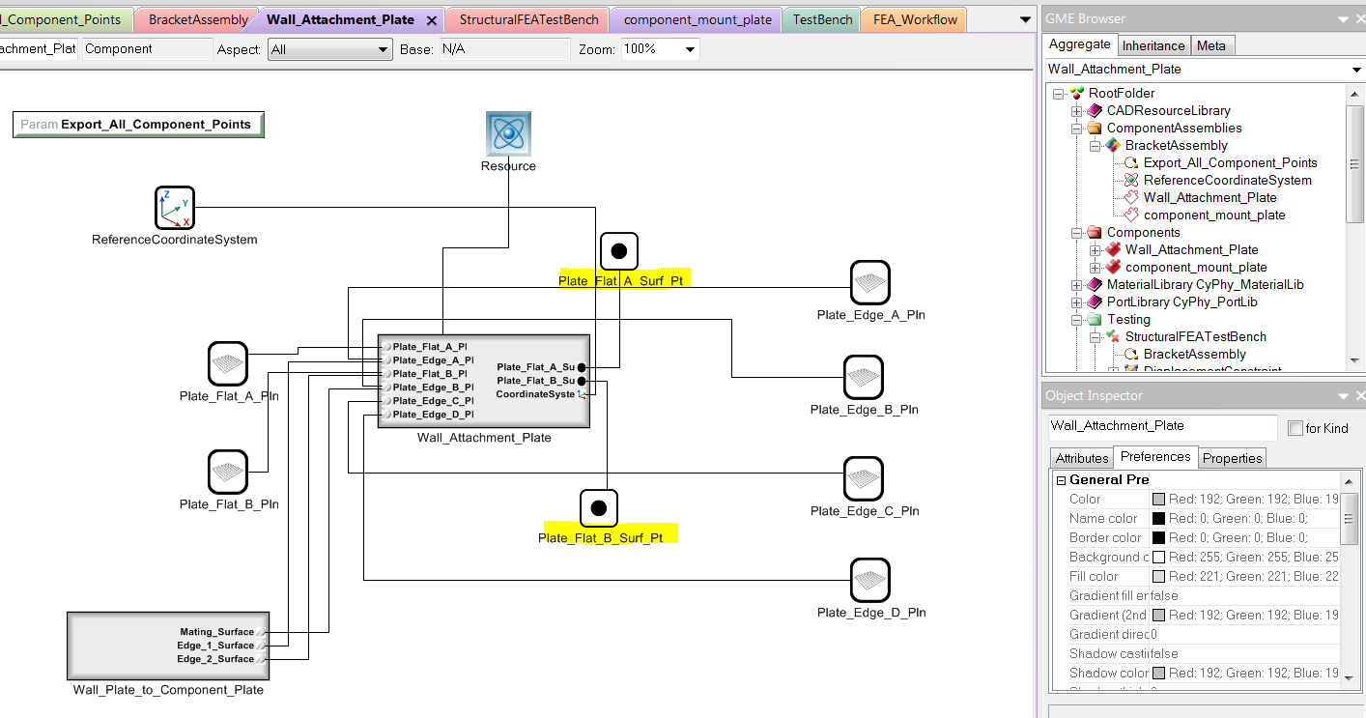

Figure 8 – Component Example with Points Necessary for Export_All_Component_Points

An example of ComputedValues.xml follows:



# Material Properties

This section describes the sources of material properties added to the material library (models/MaterialLibrary/material_library.json) subsequent to the initial release of the library .

## Composites

### General Composite Properties

NASA Design and Manufacturing Guideline for Aerospace Composites

<https://llis.nasa.gov/lesson/682>

Note – The above link has typical composite material properties.

### IM7_8551_7_Carbon_Epoxy

### T300_PR319_Carbon_Epoxy

<http://iccm-central.org/Proceedings/ICCM17proceedings/Themes/Behaviour/FAILURE%20CRITERIA%20FOR%20DES/F12.5%20Pinho.pdf>

# Simplified Representations

Most CAD systems support multiple reps (representations) of parts/sub-assemblies. For example, there could be a part that had a rep that was the complete part definition and a rep that was simplified for FEA analysis.

## Creo Model Setup

In Creo, create a simplified rep via “View” “Manage Views”.

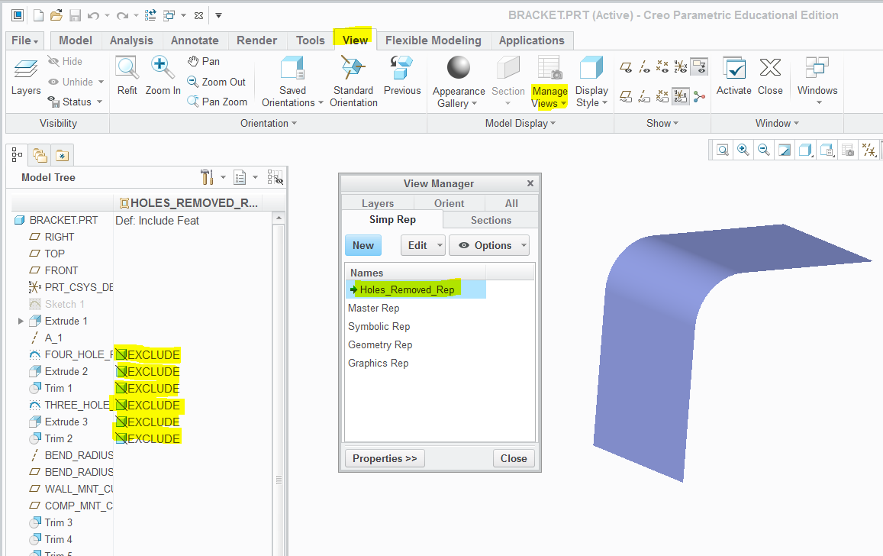

Figure 9 – Creo View “Manage Views”

The CreateAssembly program will open the Creo model with the “Master Rep” unless a rep is specified in the Test Bench.

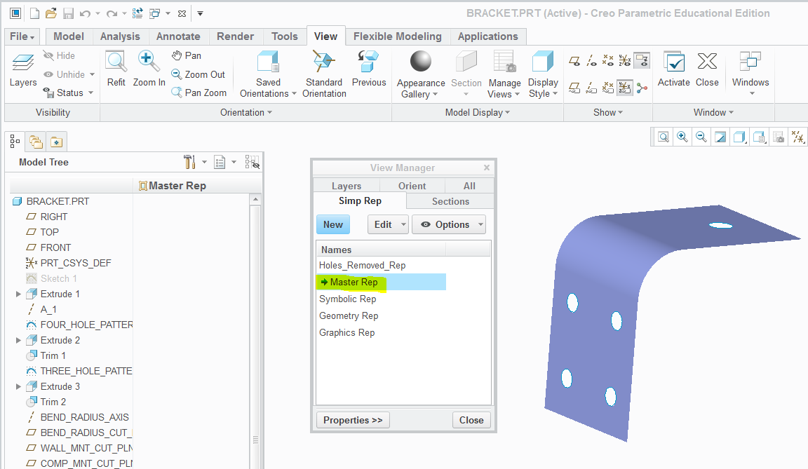

Figure 10 Creo “Master Rep” Setting

## Test Bench

To specify a particular rep be used by the CreateAssembly program, create a parameter named DEFAULT_REP with the value set to the name of the rep in Creo as shown in Figure 11.

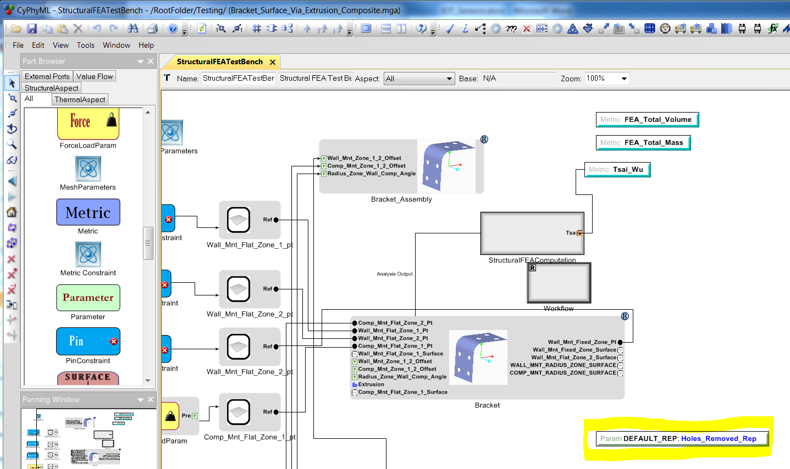

Figure 11 DEFAULT_REP Specified in a Test Bench

Note that DEFAULT_REP is case insensitive but the rep name (e.g. Holes_Removed_Rep) is case sensitive.

The DEFAULT_REP parameter applies to the entire Test Bench. Currently, with a Test Bench there is not a way to set the DEFAULT_REP parameter for a single component (i.e. part or sub-assembly). The CreateAssembly program supports setting this parameter per part/sub-assembly, but CyPhy2CAD_csharp currently does not.

The DEFAULT_REP parameter has been verified (via testing) to work with “Structural FEA Test Bench” and “Test Bench” types; however, it probably works with the other Test Bench types.

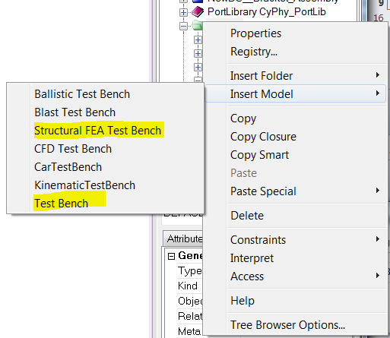

Figure 12 Test Bench Types that Have Been Verified to Work with DEFAULT_REP

# Export CAD Representations (e.g. STEP, Parasolid, etc.)

To request the export of a particular CAD representation, add to the Test Bench a parameter with the desired format.

Export_STEP_Ap203_Single_File

Export_STEP_Ap203_E2_Single_File

Export_STEP_Ap203_E2_Separate_Part_Files

Export_STEP_Ap214_Single_File

Export_STEP_Ap214_Separate_Part_Files

Export_Stereolithography_ASCII

Export_Stereolithography_Binary

Export_Inventor

Export_Parasolid

Export_DXF_2013

These strings are case insensitive, so the following would also work.

EXPORT_STEP_AP203_SINGLE_FILE

EXPORT_STEP_AP203_E2_SINGLE_FILE

EXPORT_STEP_AP203_E2_SEPARATE_PART_FILES

EXPORT_STEP_AP214_SINGLE_FILE

EXPORT_STEP_AP214_SEPARATE_PART_FILES

EXPORT_STEREOLITHOGRAPHY_ASCII

EXPORT_STEREOLITHOGRAPHY_BINARY

EXPORT_INVENTOR

EXPORT_PARASOLID

EXPORT_DXF_2013

Notes:

1. The above strings are case insensitive.
2. This works with any Test Bench type.
3. Export_DXF_2013 only exports solid models. Surface models will be empty.

Figure 13 shows an example Test Bench requesting the output of all supported CAD formats.

Note – If an exported CAD format is needed for a particular type of Test Bench to function, then there is no need to explicitly request the export of that format. For example, a “Structural FEA Test Bench” with the settings for PATRAN_NASTRN will automatically output Parasolid files.

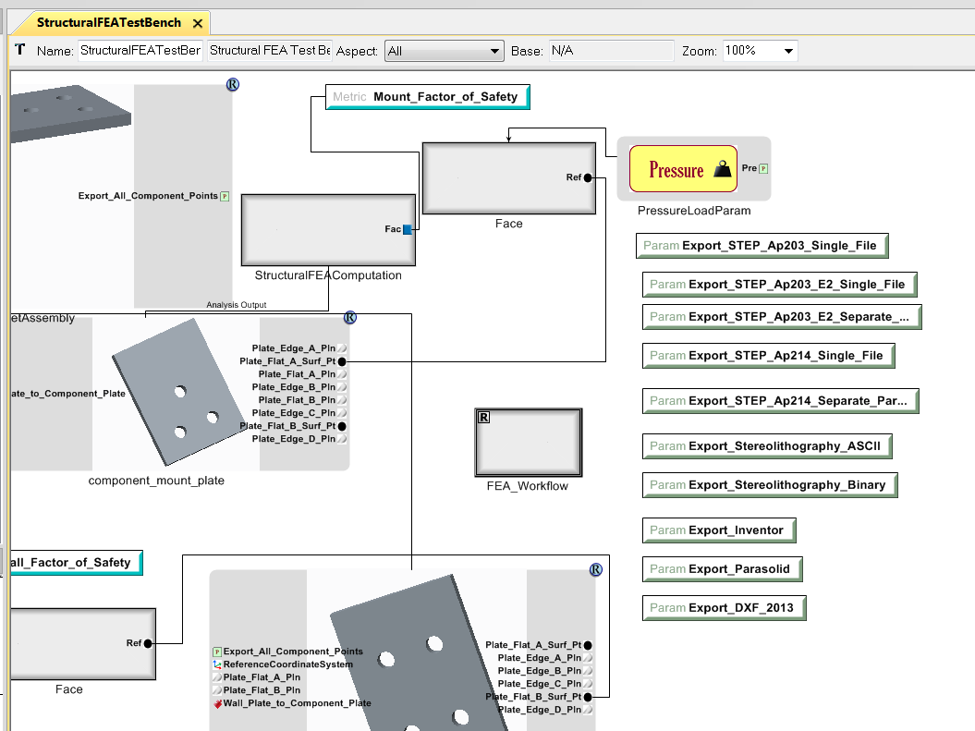

Figure 13 – Test Bench Requesting the Export of All Supported CAD Formats

# Appendix A – Links

<http://www.iccm-central.org/>

<http://www.iccm-central.org/Proceedings/ICCM16proceedings/contents/pdf/WedI/WeIM1-05sp_kaddouras225256p.pdf> and Test Factors of Safety for Spaceflight Hardware

NASA, Structural Design and Test Factors of Safety for Spaceflight Hardware

<https://standards.nasa.gov/standard/nasa/nasa-std-5001>

# Parameters

When parameters are entered in the CyPhy model, they are typically used to change dimensions in the CAD Model. For example, to change the length of a part or change where a part is positioned in an assembly.

If a unit is assigned to a parameter in the CyPhy model, then CADAssembly.xml will have a unit for that parameter. A CADAssembly.xml example follows:

e.g. <CADParameter Name="Wall_Attachment_Plate_Length" Type="Float" Value="200" _id="id142"> <Units Value="mm" _id="id143" />

Only distance (e.g. in, mm, m …) or angle dimensions (deg, rad) are supported. If CADAssembly.xml has another type dimension (e.g. lbm/in^3) then this would be considered an error. This policy is reasonable because up until now, parameters have only varied distance and angle dimensions. Varying density might be needed in the future for the case of assigning mass properties, but when that is needed then the CreateAssembly program will need to be modified.

if ( CADAssembly.xml does not have a unit set for the parameter )

e.g. <CADParameter Name="Wall_Attachment_Plate_Length" Type="Float" Value="200" _id="id142"> <Units Value="" _id="id143" />

then

do no unit conversions

assign the parameter value in CADAssembly.xml to the parameter in the CAD Model

else // units for the parameter are in CADAssembl.xml

if ( units are assigned to the parameter in the CAD Model)

then

Convert between the units in CADAssembly.xml to the units for the parameter in the CAD model

Assign the converted parameter to the parameter in the CAD model

else // no units on the parameter in the CAD model

if ( units are assigned to the CAD Model )

then

Convert between the units in CADAssembly.xml to the units for the CAD model

Assign the converted parameter to the parameter in the CAD Model

else

No information to do the conversion

In Creo this would not happen. Parts/assemblies always have units by default

If another CAD system will allow you to create a part/assembly without units, then this

would be a problem

Assign the parameter value in CADAssembly.xml to the parameter in the CAD Model

# Appendix B – Exporting Wavefront Formatted File Via Toolkit

